1. 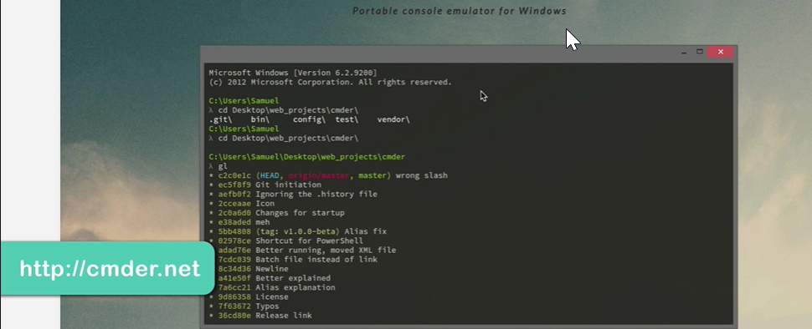  
   If working on windows, install this cmd. This is console Emulator for windows. We can use almost any commands during the course.